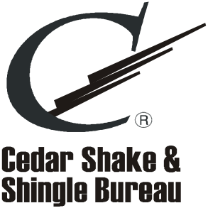

Dear Members:

It is important that we keep our members current on association events, news and marketing initiatives. Due to the Canadian anti-spam law, we are asking for express consent from all our members, regardless of location, to share information and news with you via electronic communication. Please fill out the form below and return it to the Cedar Shake and Shingle Bureau either by mail, email or fax. We appreciate your time. Thank you!

**Electronic Communication Consent Form (Check one box below)**

Yes, I give consent for the CSSB to continue to send me electronic communication.

No, I do not give consent for the CSSB to continue to send me electronic communication. Please unsubscribe me from your email list.

I do not use electronic communication at this time.

Your Name:_____________________________ Your Signature:_____________________________

Company Name:___________________________________________________________________

**Please return this form to:**

US Address: Canadian Address:

PO Box 1178 200-9292 200th Street

Sumas, WA 98295-1178 Langley, BC V1M 3A6

Fax: 604-820-0266 email: membership@cedarbureau.org